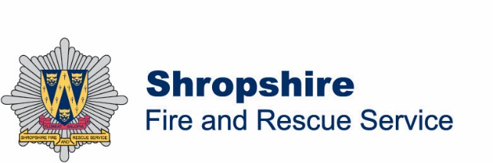 | Headquarters  St. Michaels Street, Shrewsbury  Shropshire SY1 2HJ  T 01743 260 200  F 01743 260 268  W www.shropshirefire.gov.uk  Link to IRMP

Dear Colleague
Shropshire Fire and Rescue Service is consulting on its draft Integrated Risk Management Plan (IRMP) 2021-25 and would welcome your views. The Plan sets out the changes the Service will make over the next four years under its key responsibilities including responding to emergencies, protection work with businesses and prevention activities to make communities safer. The consultation begam on the 6 July and will conclude 12 weeks later at 5pm on the 30 September 2020.
The IRMP is effectively the Fire and Rescue Authority’s contract with the community so it is vital that the views of the people who call 999, community partners and associates are listened to in moving from a draft Plan to the final version.
The IRMP contains information about communities, the risks they face and how the Service intends to manage and measure those risks. The Plan can be divided into three stages:
- Stage 1, Identifying and Assessing Risk; sets out what we believe the main risks are, and highlights some of the ways in which we’ve been dealing with them over the last few years.
- Stage 2, Managing and Reducing Risk; sets out what we are planning to do over the four-year term of the IRMP to tackle the risks we’ve identified.
- Stage 3, Measuring and Demonstrating Impact; sets out how we aim to show that our services and activities are having a positive impact on reducing risk.
The main proposals within the IRMP are:
- To make response timings easier to understand,
- To explore how technology can be used to increase productivity in preventing fires in rural communities,
- To increase activity in fire protection and regulation.
- To assess how the Service can meet growing demand through the flexible use of resources, and
- To update the Service’s Vision and Aims to will drive a culture of being more innovative, diverse, inclusive and developmental.
A short questionnaire, which can be found in the draft IRMP and online, has been prepared to help to gather views.

We have tried to make our plans easy to understand and we hope you will use the questionnaire to let us have your views, but if there are any other points you wish to make, please contact us. All our contact details and the many ways you can reach us are in the draft IRMP and online.

If there are others in your organisation who might also like the opportunity to respond to the questionnaire, then please share this link with them.

When the consultation is complete, the Service will have the fullest possible picture of risk across the county, a set of activities to manage those risks and a clear understanding of whether the Plan meets the expectations of the people of Shropshire. Your feedback will assist us in shaping the final IRMP, which will be published in April 2021.

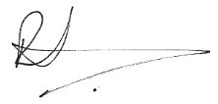
Thank you in advance for your assistance.

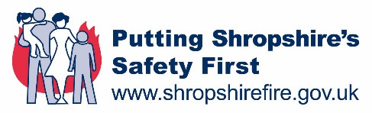
Chief Fire Officer
Rod Hammerton

