‘We Don’t Buy Crime’ – Leading from the Front

As part of my commitment to building a safer West Mercia, I would like to work with you to help prevent burglary. I fund the “We Don’t Buy Crime” – Leading from the Front project, which seeks to reduce acquisitive crime throughout West Mercia. Crime deterrent ‘Smartwater’ is part of this and it is distributed across villages and towns to protect people’s property. This offer will be a further opportunity for you to build partnerships with community groups, parish councils and engage with residents in your constituency.

As part of this proposal I am committed to providing you with the following:
- 25% of the total cost of the required Smartwater kits for a chosen area
- A reduced rate for purchasing the property marking kits
- 100% of the signage cost to promote your new WDBC area
- A dedicated PCC post to co-ordinate the project and be your first point of contact
- Police volunteer support in kind (where necessary)

Enclosed you will find the application pack. I very much look forward to hearing from you and to the prospect of working together.

Yours sincerely

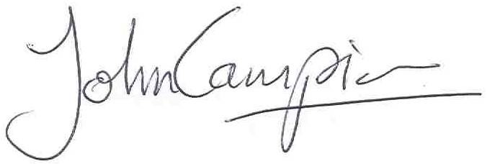
John Campion
Police & Crime Commissioner
West Mercia

