KNOCKIN PARISH COUNCIL

Clerk: Penny O’Hagan 3 Lady Ida
Kinnerley
Oswestry
Shropshire
SY10 8DN
01691 682683

5.5.20

To members of the council,

You are summoned to attend a meeting of KNOCKIN PARISH COUNCIL which will be held on the zoom platform https://us02web.zoom.us/j/87624282587 Meeting ID: 876 2428 2587 on Tuesday 12th May 2020 at 19.30

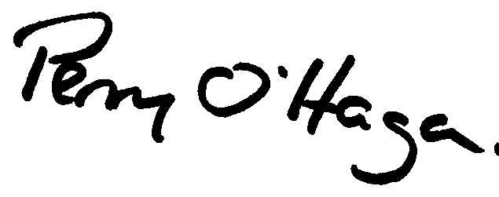

Penny O’Hagan

Clerk 01691 682683

A G E N D A

1 | ELECTION OF CHAIRMAN - To elect the Chairman of the Council
2 | ELECTION OF VICE CHAIRMAN - To elect the Vice Chairman of the Council
3 | TO ACCEPT APOLOGIES FOR ABSENCE
4 | DISCLOSABLE PECUNIARY INTERESTS  1. Declaration of any disclosable pecuniary interest in a matter to be discussed at the meeting and which is not included in the register of interests.  2. To consider dispensation applications.
5 | TO CONFIRM THE MINUTES OF THE ORDINARY MEETING HELD ON 10.3.20 and EXTRAORDINARY MEETING HELD 21.3.20
6 | VIRTUAL MEETING PROTOCOLS – to approve adoption of
7 | PUBLIC PARTICIPATION SESSION – a period of 15 minutes will be set aside for the public to speak on any items on the agenda (this may be extended at the discretion of the chairman)
8 |  | ANNUAL REVIEW OF COUNCIL REGULATIONS AND PROCEDURES  a) To review standing orders  b) To review financial regulations.  c) Assets register - To review Parish Council’s assets register.  d) Complaints Procedure - To review the Council’s complaints procedure.  e) Freedom of Information Act 2000 – To review the Council’s procedures for handling requests made under these acts  f) Data Protection Policy and data retention policy – to review
9 |  | To review Council’s Representation on the following bodies  ALC Local Area Committee, Parish Paths Partnership Officer
10 |  | Reports  a) To receive reports from meeting attended by councillors on behalf of the council  b) Unitary Councillor  c) Police
11 |  | FINANCE AND ACCOUNTS FOR PAYMENT  a) Monthly Financial Statement – to approve  b) Income – to note income received  Parish Precept £11878  Neighbourhood Fund £17309.32  c) Outstanding Payments for Approval  Payments made prior to the meeting  Highline electrics (LED conversion) 660.00  Payee Amount  Scottish Power 25.45  ALC membership Tbc  Internal Auditor B Townson 100  Knockin Assembly Rooms £4000.00  d) To consider other invoices received after the agenda has been sent out.  e) 2019- 20 Accounts - To approve the following  1. To agree responses to the annual governance statement of the Annual Governance and Accountability Return  2. To consider part 2 of the Annual Governance and Accountability Return 2019-20 year end accounts and budget report,  3. To consider internal auditors report  4. To declare that the Parish Council meets the requirements as laid out in the Annual Governance and Accountability Return to certify itself as exempt from a limited assurance review under Section 9 of the Local Audit (Smaller Authorities) Regulations 2015  f) Parish Council Insurance – to review councils insurance levels and to consider quote received from Came and Company (copy enclosed).
12 |  | a) Planning Items for Information – none at time of printing  b) Planning matters for consideration - none at time of printing  c) To consider any planning application received after the publishing of the agenda.
13 |  | PARISH MATTERS  a) Neigbourhood Fund – to receive suggestions for expenditure of  b) Bradford Arms Clock – for update
14 |  | HIGHWAYS  a) Entrance Gates – for update  b) CIL Local Application – for update
15 |  | CORRESPONDENCE -To consider list of correspondence received since last meeting – circulated via email.  SALC Updates  Covid 19 information (various sources)
16 |  | Meetings To note date and time of meetings for 2020-21

