KNOCKIN PARISH COUNCIL

Clerk: Penny O’Hagan 3 Lady Ida
Kinnerley
Oswestry
Shropshire
SY10 8DN
01691 682683
knockinpc@gmail.com

1.9.20

To members of the council,

You are summoned to attend a meeting of KNOCKIN PARISH COUNCIL which will be held at Knockin Assembly Rooms on Tuesday 8th September at 19.45 on the zoom virtual meeting platform.

Meeting ID:

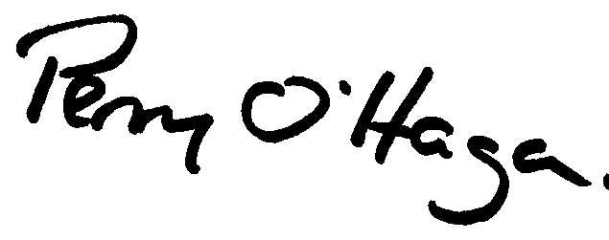

Penny O’Hagan

Clerk 01691 682683

A G E N D A

27 | TO ACCEPT APOLOGIES FOR ABSENCE
28 | DISCLOSABLE PECUNIARY INTERESTS  1. Declaration of any disclosable pecuniary interest in a matter to be discussed at the meeting and which is not included in the register of interests.  2. To consider dispensation applications.
29 | TO CONFIRM THE MINUTES OF THE MEETING HELD ON 14.7.20
30 | PUBLIC PARTICIPATION SESSION – a period of 15 minutes will be set aside for the public to speak on any items on the agenda (this may be extended at the discretion of the chairman)
31 |  | REPORTS  Police, Shropshire Council, Other reports from councillors and Clerk attending meetings or training courses on the council’s behalf
32 |  | PLANNING  a) Planning Items for Information - none at time of publishing  b) Planning matters for consideration – none at time of publishing  c) To consider any planning application received after the publishing of the agenda.  d) Reg 18 pre-submission draft local plan consultation – to consider response  e) Changes to the planning system NALC Consultation – to consider response
32 |  | FINANCE AND ACCOUNTS FOR PAYMENT  a) Financial Statement– to approve  b) Income –  c) Outstanding Payments for Approval  Payee Amount  P O’Hagan Salary 1.7.20 -30.9.20  HMRC £170.80  d) To consider other invoices received after the agenda has been sent out.  e) Annual Governance and Accountability return 2019-20 – to note that the period for the exercise of electors rights had been completed and advertised in line with the regulations.
33 |  | Parish Matters  a)Police and Crime Commissioner Survey – for consideration  b) Avenue Flooding and capacity of storm drains – for discussion  c) Face to face meetings – to consider NALC guidance
34 |  | HIGHWAYS  a) VAS Location – to discuss  b) CIL Local Application – for update  c) Outstanding Highways Issues – for update  d) Road Names in Parish – to discuss
35 |  | CORRESPONDENCE -To consider list of correspondence received since last meeting (item b circulated via email)  a) Lord Lieutenant letter  b) SALC/NALC – updates  c) Fire Authority Consultation - for consideration
36 |  | MEETINGS  a) To note date and time of November meeting

